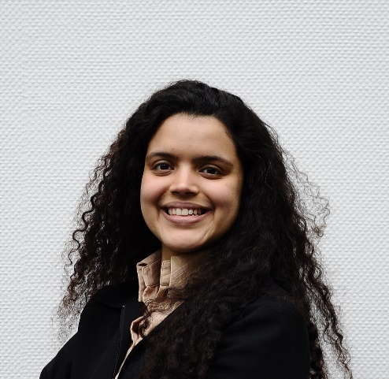
Nermeen Nabih' 02, winner of the Akila Said Award in 2002, graduated with a GPA of 3.9, majoring in Chemistry with a specialization in clinical analysis. She worked afterward as technical marketing at the german chemical company Degussa (no w Evonik) in its Cairo office for three years, followed by product development at Nestle, also in Egypt for one year before pursuing her masters in Materials Science in Ulm, Germany, 2006-2008. After finishing her master's studies and the thesis, she pursued her Ph.D. at the Max Planck Institute for Polymer Research in Mainz, Germany. The Ph.D. project was in cooperation with Henkel in Düsseldorf, which was her first contact and experience with research in industries. After her Ph.D., she joined the R&D Team of Continental Tires in Hanover, Germany, in 2011 and currently holds the position of Senior Reinforcement Developer. Nermeen is the co-author / co-inventor of about 15 publications and patents, with more planned in the pipeline.

